ICA 9 - Using Annual Reports

Company Name: APPLE

10-k Filings:
Aapl-20230930

Aapl-20240928

Aapl-20250927

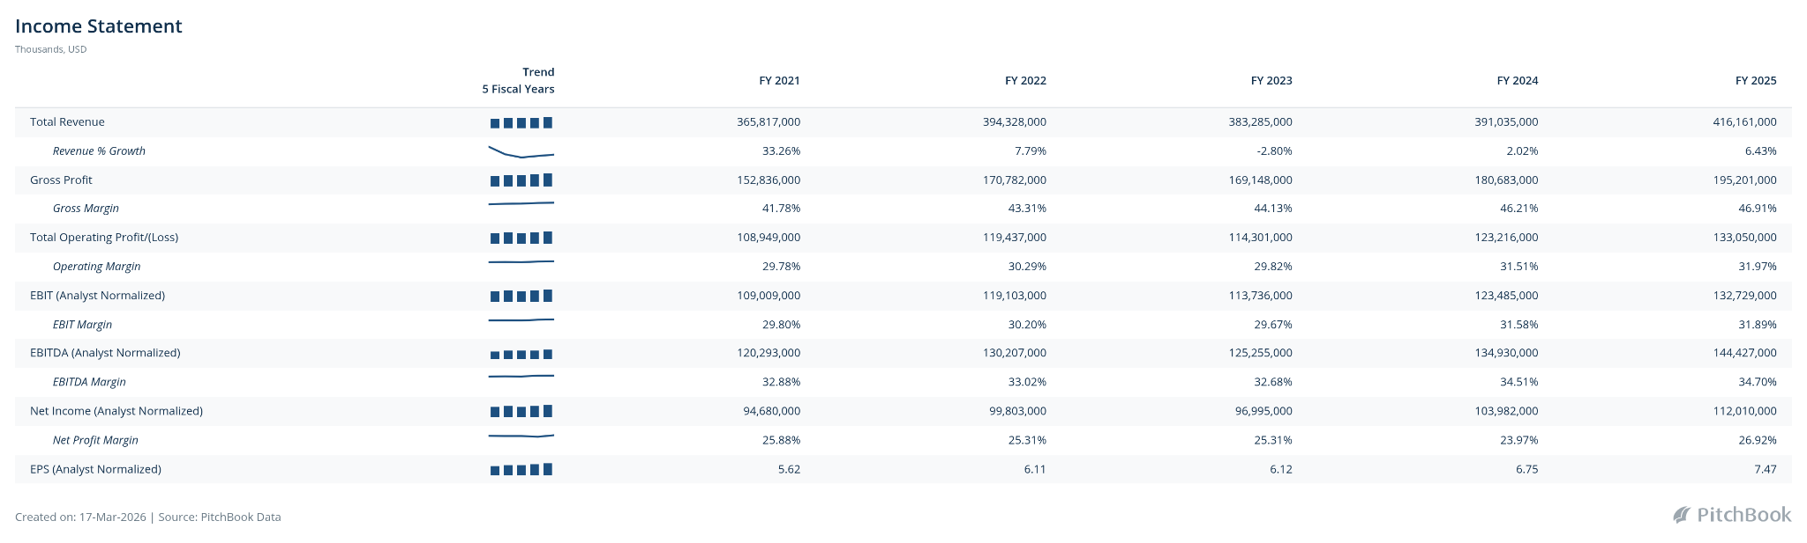

KPI trend table:

KPI | 2025 | 2024 | 2023 | Trend
Revenue | 416,000,000 | 391,035,000 | 383,285,000 | 
Net Income | 112,010,000 | 103,902,000 | 96,996,000 | 
Gross Margin | 46.81% | 46.21% | 44.13% | 
Operating Margin | 31.97% | 31.51% | 29.82% | 
EPS | 7.47 | 6.75 | 6.12 | 
EBIT | 31.89 | 31.58 | 29.67 | 
EBITDA | 114,427,000 | 134,930,000 | 125,255,000 | 

Computed Ratios:

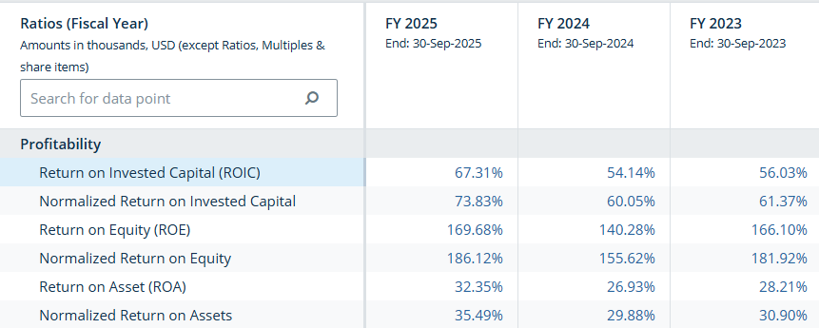
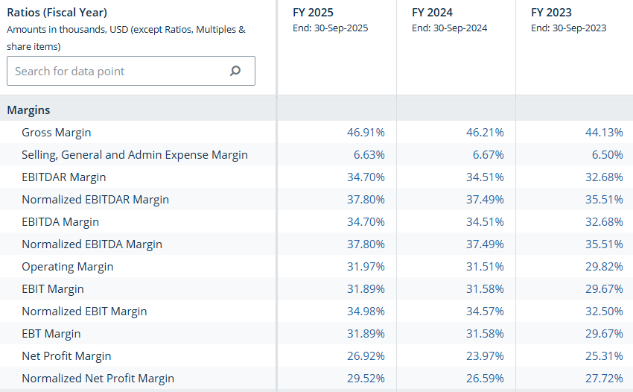

Investment thesis: Apple makes steady money because people stay in its ecosystem (through pricing power, recurring service revenue, and more), allowing it to earn consistent profits and grow over time.

Risks:
- Regulatory Pressure
- Dependency on iPhones
- Innovation Risk
- Supply Chain Risk

